**LANGUAGE SECTION (40 pts.)**

**A. Fill in the blanks with the correct forms of the verbs in parentheses. (1 pt. each; 12 pts.)**

Dear Mom,

How are you? How’s Dad? I’m great. I have big news! I (1) (meet)

a good-looking, successful man last month. I (2) (like) him so much! His name is Richard, and he is a lawyer at the Universal Studios in California. Normally,

he (3) (live) in Boston, but now he is in Boston for his brother

Alan’s wedding. Alan is my classmate, and he (4) (get) married next

Month. OK, so here is the big news. I made a decision! I (5) _____________ (move) to Los Angeles because I would like (6) (become) an actress. I (7)__________________ (take) acting lessons nowadays. I (8) ______________________ (tell) you when we spoke on the phone yesterday because I didn’t want you to worry about me. I (9) ­­___(buy) my plane ticket last week. My plane (10) ________(leave) tomorrow at noon. Don’t worry, I (11)______________________ (spend) any money for hotel in Los Angeles. Richard promised to take care of me. He has a big apartment. I’m so excited Mom! Please don’t worry about me. I’m so happy right now. I’m looking forward to (12) _______________ (hear) from you. Say hello to Dad!

Love, Cindy

**B. Write questions about the underlined words. (2 pts. each; 8 pts.)**

**1.** Cindy saw an old friend.

?

**2.** They went to a restaurant.

?

**3.** They eat pizza once a week.

?

**4.** Cindy likes drinking lemonade.

?

**D. Complete the dialogue with ONE question. Write your answer in the blank. (2 pts. each;**

**4 pts.)**

**Amy:** I know you are from Canada. (1) ?

**Bob:** Actually, no. I went to college here in the United States.

**Amy:** Really? That’s interesting. (2) ?

**Bob:** In college? Chemistry.

**E. Fill in each blank with ONE word ONLY. (1 pts. each; 12 pts.)**

Hi, my name is Olivia. I’m married (1) _ Ben. We are from Great Britain. We are

(2) 25 years old. Ben is my best friend, (3) he is also my boss. We work at the (4) office. We never do things (5) . Actually, we do everything together. We’re really interested (6) sports. We like outdoor activities. On Saturdays, we go to the Rocky Mountains for rock climbing, (7) we go to the park in the city for rollerblading. It changes every Saturday. (8) winter holidays, we go skiing. (9) the weather is hot and nice, we go to the beach. Today, it’s really (10) . It’s 2˚C. It’s also very windy and rainy, (11) we’re at home. We really like hanging out (12) __________ each other.

**READING SECTION (35 pts.)**

**TEXT I. Read the following text and answer the questions. (14 pts.) ICE DIVING**

1 Some people go swimming under the ice for fun. Did you know that? It is very similar to going snorkeling under an extremely cold sea, and it is called ice diving. It is not a normal sport: you need to be a professional diver. Before they go ice diving, the divers put on special warm clothes, and then, they wear a special diving suit called a drysuit. This suit is different from a normal diving suit because there is air in it. The air keeps the divers warm, and it also keeps them high in the water. Ice divers still need oxygen tanks, so they carry their oxygen tanks on their backs.

2 A typical ice diver stays under the ice for fifteen minutes. The diver opens a hole in the ice, and then, swims under **it**. The other divers watch and wait. They are ready to help the diver.

3 So, what's it like, under the ice? Ice divers say it's another world – a bright world of strange animals, plants and rocks, and amazing shapes and colors. It's also great fun. When they are in the water, divers can turn and put **their** feet under the ice and walk on the ice.

4 There are many popular ice diving places all over the world. McMurdo Sound in Antarctica is the number one place. Because it is very far away and water is too cold – around -40°C, divers can only dive in the summer months from September to February. During this time, the water temperature is -1°C. There are some very popular ice diving places in Europe, too. **These places** are mostly fresh water lakes. The Mellan Markiven Lake in Sweden and Nionplas Raamsdonksveer in the Nederlands are good for fish watching. Denmark, Switzerland, and Poland are also famous for their ice diving lakes, but they do not have good fish life.

**A. What do following words refer to? (1 pt. each; 3 pts.)**

1. it (para. 2) :

2. their (para. 3) :

3. These places (para. 4) :

**B. Read the text, and mark the statements true (T) or false (F). (1 pt. each; 3 pts.) T F** 1. Ice diving is not a sport for every diver.

**T F** 2. Ice divers do not need oxygen tanks.

**T F** 3. Ice divers stay under the water for many hours.

**C. Answer the following questions. (2 pts. each; 8 pts.)**

1. What is different about an ice diving suit?

.

2. Write two things a diver can see under the ice.

a) .

b) .

3. When can divers go diving into McMurdo Sound in Antarctica?

.

4. Which countries do people go for ice diving in Europe? Write two.

a) .

b) .

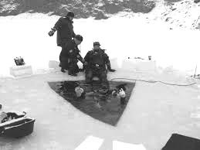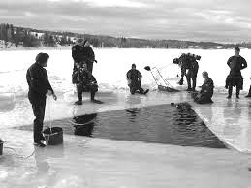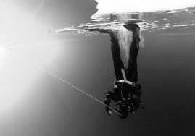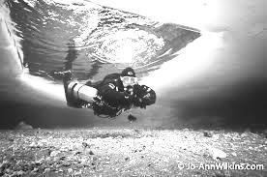

**TEXT II. Read the following text and answer the questions. (16 pts.)**

1 They paint their faces. They wear bright, colorful clothes. They wear funny wigs on their heads, and they have very big shoes, so people laugh at them. Who are they? They’re clowns, of course, but these clowns have a very dangerous job – they’re rodeo clowns.

2 Bull riding competitions, called rodeos, are very popular in the US. Every year, bull owners organize over 650 rodeos **there**. Rodeo clowns work at these competitions. They have exciting and amusing performances, but their job also has a serious side – they save the bull riders. When riders fall down, rodeo clowns run in front of the bull, shout and throw their hats. The bull becomes very angry, and runs after them. It may look fun, but a good rodeo clown needs to think really fast. It is a very dangerous job. Injuries are a part of it. The rodeo clowns usually fall down a lot, and break their arms, legs, or ankles. Many rodeo clowns usually go to the hospital after the performances and see the doctor for their injuries.

3 There are two types of rodeo clowns. One of them is called the “barrel man.” The barrel man sits in a large round container with a flat top and bottom, called a barrel, in the middle of the rodeo ring and entertains the people. When the rider needs help, **he** calls the barrel man. The barrel man jumps out of the barrel and tries to get the bull angry. He doesn’t want to die, so when the bull runs at him, the barrel man jumps back into the barrel. The other clown is the “bullfighter.” His job is to get very close to the bull, and jump on **its** back. Bull riders really like the bullfighters and at the end of November every year, they choose the “Bullfighting Clown of the Year.” There is also a competition, called the “World Bullfighting Championship.” The rodeo clowns choose the best bullfighter in this championship.

bull rider bull

←

←

wig →

↓

barrel

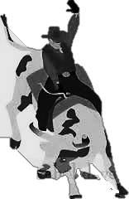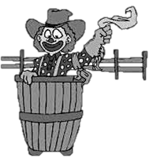

**A. What do following words refer to? (1 pt. each; 3 pts.)**

1. there (para. 2) :

2. he (para. 3) :

3. its (para. 3) :

**B. Read the text, and mark the statements true (T) or false (F). (1 pt. each; 3 pts.) T F** 1. It looks fun, but rodeo clowning is actually a hard job.

**T F** 2. A rodeo clown usually has injuries after the performances.

**T F** 3. The barrel man sits far away from the rodeo ring.

**C. Answer the following questions. (2 pts. each; 10 pts.)**

1. What do rodeo clowns wear? Write two.

a) .

b) .

2. What does a rodeo clown do when a rider falls down?

.

3. a) How many types of rodeo clowns are there?

.

b) What are they?

.

4. Why does the barrel man jump back into the barrel?

.

5. When do the bull riders choose the “Bullfighting Clown of the Year”?

.

**VOCABULARY SECTION (1 pt. each; 5 pts.)**

**Read the following text, and fill in each blank with a word from the box. There are more words than you need. Do not change the form of the words. Use each word only ONCE.**

**companies unusual favorite poor size rules**

**rich transportation documentary**

Do you know Segway? It is also called Ginger, and it looks like a scooter. It is a means of

(1) (2)

. It is different from other systems, and it looks

. Because it carries only one person, it is also very personal. It is small

in (3) , and it is easy to ride. It is also very safe. Segway is popular in

Europe and the US.

In some cities, people do not use cars. Instead, they use Segway because they don’t want to wait in the traffic. Also, in some European cities, cars cannot go into the old and historical parts. In these cities, people travel around these parts on Segway. Some travel agencies organize Segway tours. They show the basic (4) of riding Segway. The instructors teach going forward, turning right and left, and they also teach how to stop.

At the moment, Segway is a little expensive, so only (5) people can buy it.

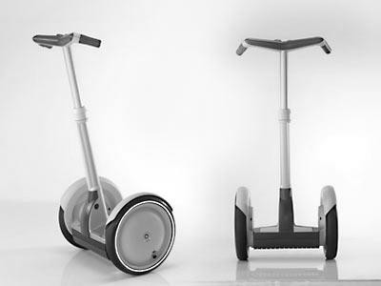

**SECTION TOTAL:**

**/ 35 pts.**

**2014-15 BEGINNER GROUP MIDTERM 01 ANSWER KEY**

**LANGUAGE SECTION (40 pts.)**

**A. 1 pt. each; 12 pts.**

1. met

2. like

3. doesn’t live

4. is going to get/ will get

5. am going to move

6. to become

7. am taking

8. didn’t tell

9. bought

10. is going to leave/ will leave

11. am not going to spend / will not spend

12. Hearing

**B. 2 pts. each; 8 pts.**

1. Who did Cindy see

2. Where did they go

3. How often do they eat pizza

4. Who likes drinking lemonade

**D. 2 pts. each; 4 pts.**

1. Did you go to college there / in Canada

2. What did you study (in college)?

What was your department?

**E. 1 pt. each; 12 pts.**

1. to

2. both

3. but / and

4. same

5. alone

6. in

7. or

8. During / In

9. When

10. cold

11. so

12. with

**READING SECTION (35 pts.) TEXT I. (14 pts.)**

**A. 1 pt. each; 3 pts.**

1. the ice

2. divers’

3. (Popular) ice diving places in Europe

**B. 1 pt. each; 3 pts.**

1. T 2. F 3.F

**C. 2 pts. each; 8 pts.**

1. There is air in it.

2. **1 pt. each; 2 pts. Please accept any two:**

strange animals / plants / rocks / amazing shapes / (amazing) colors / fish

3. (Divers / They can go diving into McMurdo Sound (in Antarctica)) In the summer months /

from September to February / between September and February.

4. **1 pt. each; 2 pts. Please accept any two:**

Sweden / (the) Nederlands / Denmark / Switzerland / Poland

**TEXT II. (16 pts.)**

**A. 1 pt. each; 3 pts.**

1. in the US

2. the rider

3. (the) bull’s

**B. 1 pt. each; 3 pts.**

1. T 2. T 3.F

**C. 2 pts. each; 10 pts.**

1. **1 pt. each; 2 pts. Please accept any two:**

(They wear) bright, colorful clothes / funny wigs (on their heads) / (very) big shoes.

2. (When a rider falls down) a rodeo clown runs in front of the bull, shout, and throw his hat.

3. **1 pt. each; 2 pts.**

a) (There are) two (types of rodeo clowns.)

b) (They are) The barrel man and the bullfighter.

4. (He jumps back into the barrel) (because) he doesn’t want to die.

5. (They choose the “Bullfighting Clown of the Year”) at the end of November every year.

**VOCABULARY SECTION**

**1 pt. each; 5 pts.**

1. transportation

2. unusual

3. size

4. rules

5. rich